Stage 1 — Kinesis
Executive Solution Proposal: Data-to-Persona-to-Message Architecture
A simple, practical solution approach for using EBI and internal data to identify customer personas, guide WhatsApp conversations, and improve MyACUVUE registration from 7% toward 14%.

Scope of the document
This proposal explains how Stage 1 shold turn available data into a usable decision engine for WhatsApp engagement. The objective is simple: understand each customer better, identify the likely barrier stopping them from registering on MyACUVUE, and send the most relevant message at the right point in the journey.
The solution combines two types of data. EBI data gives market and category context. Internal or sample data gives customer-level context. Together, they help create a persona view that can be simplified for WhatsApp and used to select the right message. This creates a measurable path from customer conversation to MyACUVUE registration, which is the key business outcome.

The pipeline
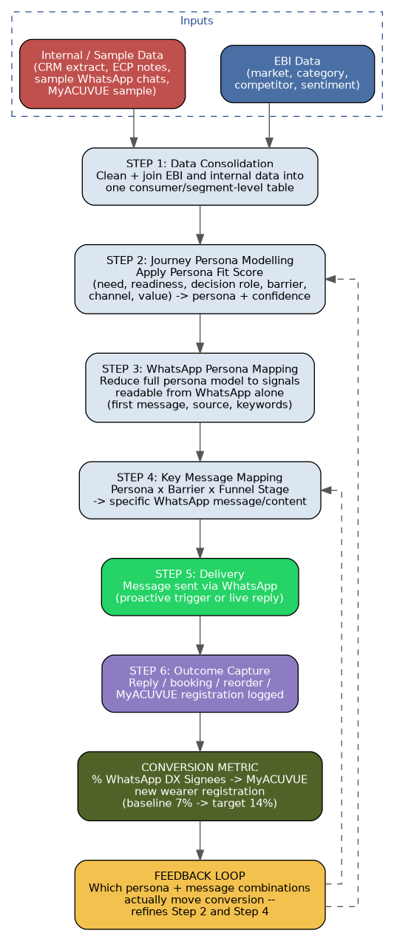
Figure 1 — From raw data to a delivered WhatsApp message, with the feedback loop that improves both the persona model and the message mapping over time.

Walking through each step

Inputs: EBI data and internal/sample data
The proposed solution starts with two data inputs. EBI data provides the external view: market size, category movement, competitor activity, review sentiment, and broader customer behaviour. This helps the team understand where the opportunity sits and what is happening in the market.
This is representative need to see what all data we get
Internal or sample data provides the customer view. This may include CRM extracts, purchase history, ECP visit notes, reorder timing, sample WhatsApp conversations, and MyACUVUE registration records. For Stage 1, full live access is not required. A good representative sample is enough to build and validate the model before moving toward production.

Step 1 — Data consolidation
The first technical step is to bring EBI and internal data into one usable structure. Wherever possible, the data should be joined at customer level. If customer-level joining is not available, it should be joined at segment level with clear rules. This is important because market-level data and customer-level data cannot simply be forced into one flat table without losing meaning. The design should preserve both views and connect them in a controlled way.

Step 2 — Journey Persona modelling
Once the data is consolidated, the Persona Fit Score model is applied. Each customer or segment is assessed on simple decision factors: need state, readiness, decision role, barrier pattern, preferred channel, and value potential. The model then assigns a Journey Persona and a confidence level. High-confidence personas can be used for planning and targeting. Low-confidence records should be handled carefully and should not be forced into a persona.
This creates the full planning persona. It is useful for segmentation, dashboarding, and campaign planning. However, it may contain more information than is available during a live WhatsApp conversation, so it needs to be translated into a simpler WhatsApp-ready version.

Step 3 — WhatsApp Persona mapping
The WhatsApp Persona is the real-time version of the Journey Persona. It uses signals that are available during the conversation, such as the first message, entry source, keywords used, reply timing, and any light CRM match. This makes the solution practical for live engagement, even when full customer data is not immediately available.
In the proposed architecture, the Journey Persona supports planning, while the WhatsApp Persona supports in-the-moment decisioning. As more customer actions are captured, the two views can be compared and improved. This keeps the system practical at the front end and more accurate over time.

Step 4 — Key message mapping
Once a WhatsApp Persona is identified, the system selects the message using a simple mapping: persona × barrier × funnel stage → message. This avoids manual decision-making for every conversation. The team can prepare approved message options in advance, tag them clearly, and use the mapping table to decide what should be sent next.

Step 5 and 6 — Delivery and outcome capture
After the message is delivered, the system captures the next customer action. This could be a reply, a click, a booking, a reorder, or a MyACUVUE registration. These actions are important because they show whether the message helped move the customer forward.

The feedback loop — how this actually moves the 7% to 14% number
The feedback loop is what makes the solution measurable. Every message should be linked to the persona, the barrier, the funnel stage, and the outcome. Over time, this shows which message combinations are helping registration and which ones are not. The learning can then improve both the persona model and the message mapping. This is how the solution moves from a one-time campaign setup to a smarter engagement engine that supports the 7% to 14% registration goal.

Assumptions this design depends on
- EBI data must be available in a usable, exportable format early enough in Stage 1 to inform the consolidated dataset. It should not only be available as a finished dashboard that can be viewed but not used for modelling.
- The internal or sample data should be a genuine sample of real customer and conversation records, rather than synthetic or heavily aggregated data. The persona model needs real variation to learn from.
- A reasonable sample size should be available for each cohort, including existing customers, new customers, active considerers, and lapsed customers. If a cohort is thin, the model should flag lower reliability instead of treating all cohorts as equally confident.
- Sample WhatsApp conversations, where available, should be recent and representative of how customers actually write. Older or unrepresentative samples could distort the WhatsApp Persona mapping.
- The 7% baseline conversion figure should be clearly defined using the same population, measurement window, and definition of “eligible trial consumer.” This ensures the pipeline is measured against a fair comparison point.
- Full CRM or MyACUVUE API access is not required for Stage 1. The pipeline is intended to be built and validated first using sample or batch data. Live integration belongs to the Disruptor and Activator phases.

What gets built in Stage 1, specifically
Stage 1 should deliver a clear, testable solution design rather than a full production platform. The key outputs are:
1. A working Persona Fit Score model that uses the consolidated dataset to assign a Journey Persona and confidence tier to each customer or segment in the sample.
2. A WhatsApp Persona schema that defines the real-time signals used to identify a likely persona during a WhatsApp conversation.
3. A message decision table that maps persona, barrier, and funnel stage to the most relevant approved message.
4. A measurement framework that connects message delivery to MyACUVUE registration, including the event definition, source system, and measurement window.
The recommended Stage 1 outcome is a validated model, a set of decision tables, and a clear technical specification for the next phase. This gives leadership a simple view of the business value, while giving the solution team enough detail to design the live orchestration engine in the Disruptor and Activator phases.

